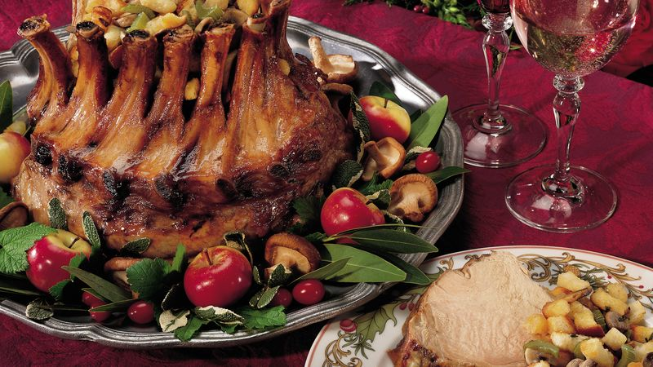

Ingredients
8- to 10-lb pork crown roast (about 16 to 18 ribs)
2
teaspoons salt
1
teaspoon pepper

Mushroom Stuffing
2/3
cup butter or margarine
2
medium stalks celery, chopped (1 cup)
1
medium onion, finely chopped (1/2 cup)
1
lb fresh mushrooms, sliced (6 cups)
8
cups unseasoned croutons
1
tablespoon chopped fresh or 1 teaspoon dried sage, thyme or marjoram leaves
1
teaspoon poultry seasoning
1
teaspoon salt
1/2
teaspoon pepper

Steps
Prevent your screen from going dark while you cook.
- 1
Heat oven to 325°F. Sprinkle pork with salt and pepper. On rack in shallow roasting pan, place pork with bone ends up. Wrap bone ends in foil to prevent excessive browning. Insert ovenproof meat thermometer so tip is in thickest part of pork and does not touch bone or rest in fat. Place small heatproof bowl or crumpled foil in crown to hold shape of roast evenly. Do not add water.
- 2
Roast uncovered 2 hours 40 minutes to 3 hours 20 minutes.
- 3
Meanwhile, make Mushroom Stuffing. About 1 hour before pork is done, remove bowl and fill center of crown with stuffing. Cover stuffing with foil for first 30 minutes.
- 4
Remove pork from oven when thermometer reads 150°F; cover with tent of foil and let stand 15 to 20 minutes or until thermometer reads 160°F. (Temperature will continue to rise about 10°F, and pork will be easier to carve.) Remove foil wrapping from bone ends. To serve, spoon stuffing into bowl and cut pork between ribs.

