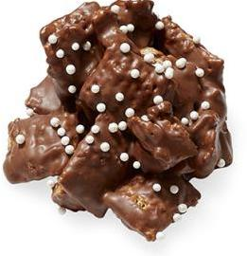

NO BAKE PEANUT BUTTER-CHOCOLATE CLUSTERS

Ingredients

1 1/4 cups semisweet chocolate chips
1 1/4 cups peanut butter chips
4 teaspoons vegetable shortening
4 cups cereal squares (such as Chex)
1/2 cup salted roasted peanuts, roughly chopped
White nonpareils, for decorating

Directions
- Line a baking sheet with parchment paper. Combine the chocolate chips, peanut butter chips and shortening in a large heatproof bowl set over a saucepan of simmering water (do not let the bowl touch the water). Stir until melted and smooth, 2 to 4 minutes. Remove the bowl from the pan and add the cereal and peanuts. Stir with a rubber spatula until evenly coated.
- Spoon the cereal mixture into clusters (about 2 tablespoons each) onto the prepared baking sheet; sprinkle with nonpareils. Refrigerate until firm, about 30 minutes.

