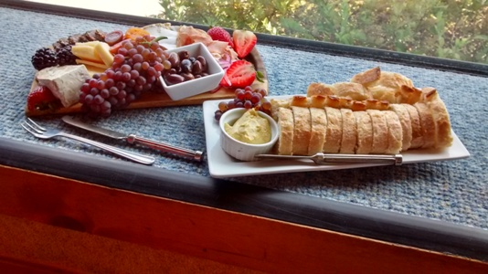
Say Cheese! Karen O’s favorites
- My absolute favorite cheese. Fiore di Sardegna is a firm cheese made from sheep’s milk. It is similar to parmesan. It will slice but is a little bit crumbly. Wonderful as a snacking cheese, especially with olives. But it can also be used in cooking or grated as a topping. I get it on Federal Hill, Providence, RI.
- I recently discovered Gjetost (pronounced yay toast). It is a Norwegian cheese made from goat’s milk. It is caramel brown in color, soft and slightly sweet. I had it for breakfast on toast with jam. Wonderful.
- Cheddar, any kind, any place. I never met a cheddar that I didn’t like, but the sharper the better. It is a hard cheese that is great for snacking, cooking, you name it. It is the second most popular cheese in the United States. I especially like it with pears or fig jam.
- Brie cheese is a soft, versatile cheese and yes you can eat the rind. Especially fabulous when baked in pastry and served with some sort of jam or fruit spread.
- Fresh Mozzarella is a high-moisture cheese made from cow’s milk in the United States, but from buffalo’s milk in Italy. With tomatoes and basil and balsamic vinaigrette is my favorite. But I use it in cooking too. I just made eggplant parm and added a layer of fresh tomatoes, basil and mozzarella between the fried eggplant.
- Bleu (or blue) cheese is believed to have been discovered by accident when cheeses were stored in natural temperatures and moisture-controlled caves, which happened to be favorable environments for many varieties of harmless mold. It was moist in the cave so the mold would form. According to legend, Roquefort was discovered when a youth, eating a lunch of bread and ewes' milk cheese, abandoned his meal in a nearby cave after seeing a beautiful girl in the distance. When he returned months later, the mold (Penicillium roqueforti) had transformed his cheese into Roquefort. Bleu cheese is sharp and salty, soft but it crumbles. Love it on a wedge salad and especially with grapes or stone fruits like peaches and plums. Wonderful with nuts too.

Ian’s Favorites
- Manchego, made with sheep’s milk. Grassy flavor.
- Gruyere, nutty flavor, rich, hard cheese. Can be a little expensive but worth the splurge.
- Asiago, sharp, tangy flavor, grates well, use as you would Parmesan
- Gorgonzola, a creamy, Italian bleu cheese made with cow’s milk.
- Brie, made with cow’s milk, has an outer rind with a creamy center.
- Burrata, similar to fresh mozzarella, little balls of soft cheese with a creamy center.
Ian says check out cheese.com for everything cheese and look for the PBA special about Sister Noella, “The Cheese Nun”.

