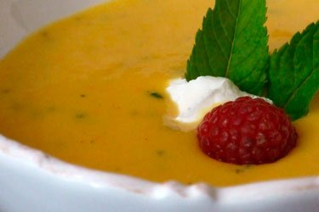
Chilled Peach Soup
From Sweet Georgia Peaches
4 cups fresh peaches, peeled and sliced (about 5 medium peaches)
1 cup white wine (such as pinot grigio)
1 cinnamon stick (3-inch)
1/8 teaspoon cardamom (I usually leave this out, since I rarely have it in my spice rack)
2 tablespoons honey
juice ½ lemon
6 ounces plain yogurt
¼ teaspoon vanilla extract
fresh mint for garnish
FIRST In a medium saucepan, combine peaches, wine, cinnamon, and cardamom over medium-high heat. Bring to a boil, reduce heat, cover, and simmer for 10 minutes or until peaches are soft.
NEXT Remove peaches from heat and let cool slightly. Puree in food processor or blender until smooth. Add honey, lemon juice, yogurt, and vanilla and pulse until smooth. Thicken with additional yogurt if desired.
LAST Refrigerate until chilled. Ladle into bowls, garnish with fresh mint, and serve.

