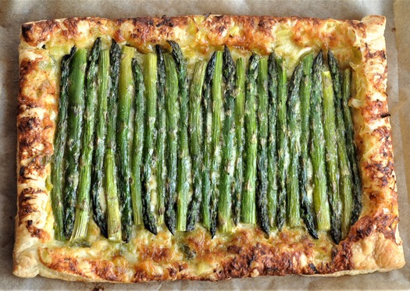

Asparagus, Leek and Gruyère Tart
Serves 6.
Note: Look for asparagus that is of thin or medium thickness to ensure the tart and asparagus are done at the same time. If you can’t find crème fraîche, you can substitute sour cream. From Meredith Deeds.
• 1 tbsp. unsalted butter
• 1 medium leek, white and tender green, halved lengthwise, thinly sliced crosswise and rinsed well
• 1 lb. asparagus, trimmed
• 1 tbsp. olive oil
• 3/4 tsp. salt, divided
• 1/2 tsp. freshly ground black pepper, divided
• 1 sheet frozen puff pastry (about 1/2 lb.), thawed
• 2 c. shredded Gruyère cheese
• 1/2 c. crème fraîche
• 1 egg yolk
• 1/8 tsp. freshly grated nutmeg
• All-purpose flour, for dusting
Directions
Preheat oven to 425 degrees.
Heat the butter in a large skillet over medium heat. Add the leeks and cook, stirring, for 8 minutes or until softened and slightly browned. Remove from heat and let cool for 10 minutes.
Place the asparagus on a large baking sheet. Drizzle with the oil and season with 1/4 teaspoon salt and 1/4 teaspoon pepper. Place in oven to roast for 3 minutes. Set aside.
In a medium bowl, combine the sautéed leeks, Gruyère, crème fraîche, yolk, nutmeg, remaining 1/2 teaspoon salt and 1/4 teaspoon pepper.
Roll out the puff pastry into a 10- by 16-inch rectangle on a floured surface. Transfer to a parchment-lined baking sheet. Spread the leek/cheese mixture onto the puff pastry, leaving a 1/2-inch border around the edges. Fold 1/2-inch of the pastry over the filling on all sides. Arrange the asparagus on top of the leek/cheese mixture and bake for 20 to 25 minutes, or until the tart is browned on the sides and bottom and the asparagus is tender.

