Lisa’s Basic Ice Cream Mix fits a 4 quart machine. Every machine is different so the recipe will have to be adjusted per the machine. Lisa also adjusts the sugar depending on flavor.

6 eggs, beaten until frothy
3 ½ cups sugar
1 quart heavy cream
1 pint light cream
2 tsp. vanilla
¾ teaspoon salt

Mix and chill well before putting it in the machine.

This mix makes an awesome ginger peach ice cream. You’ll need about 10 peaches, peeled, sliced and pureed. Mix in about 5 cups of puree and about a thumb-sized piece of ginger, grated. Perfect for summer.

I also use this mix for the peppermint ice cream but I lower the sugar to just ¾ cup. I usually use a bag of starlight mints but I’ve also used a bunch of leftover candy canes. Mix everything together and put the mints in. It takes about 2 days in the fridge for the mints to dissolve. Stir twice a day until the chunks are all gone. You could just use peppermint extract but using peppermint candy adds the delightful pink color.

I’ve found this basic mix to be very versatile and forgiving. Just adjust the sugar. You can also lower the fat by using milk instead of light cream but I figure if you are going to the trouble of making homemade ice cream, you’ll want it to be an extra special treat and for that, you have to have the high butter fat.

As I said, all machines are different but they mostly have the same basic principle. Lots of ice and salt to freeze the mix while churning. In the winter when my house is under 70º, I use about one bag of ice and one standard can of salt. In the summer, it takes about double the ice and salt. In the real dog days of summer, it would probably be even more. I avoid the warmest days of the year because it becomes really difficult to transfer from the machine to the storage tubs without melting.
Ice cream makers
Traditional Ice Cream Maker, ice bath in a wooden bucket surrounding a tin cylinder with a hand cranked blade or motorized blade. Makes one QT to ½ gallon of ice-cream.
Average cost $25.00-75.00
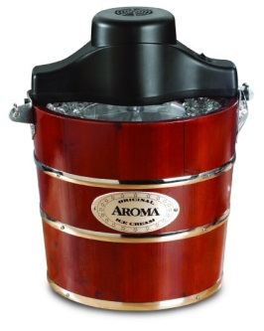
Ice-cream maker with self-contained insulated freezer cylinder eliminates the need for ice. Motorized blade. Makes about one QT of ice-cream at a time.
You need to let the insulated cylinder freeze in between uses. Average cost $20.00-65.00
