GRILLED CORN – Do not shuck you corn, soak your corn in cold water (right in the sink) for about 20 to 30 minutes. Place on hot, clean grill and grill for about 15 minutes, turning to cook each side.

FLAVORED BUTTERS
Spicy Buffalo Butter: mix ½ cup unsalted butter (room temp) with 2 ounces blue cheese crumbles, 1 tbs frank’s house sauce and 1 tbs chopped chives
Cinnamon Chipotle Butter: mix ½ cup unsalted butter (room temp) with 1 tsp orange zest, 3/4 tsp cinnamon, ¼ tsp chipotle powder, ¼ tsp chili powder and pinch of salt
Cilantro Lime Butter: mix ½ cup unsalted butter (room temp) with zest and juice form ½ a lime, 1 tbs chopped cilantro, pinch of red pepper flakes and pinch of salt
Once you mix your butter, place in butter mold or place on a piece of plastic wrap and shape into a log, roll in plastic. Refrigerate till butter hardens.
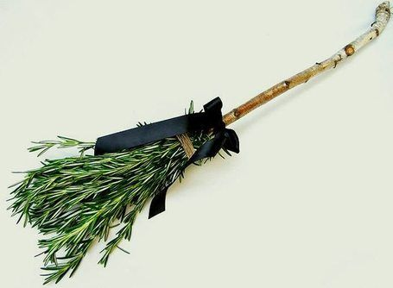
ROSEMARY BROOMS
Melt butter and flavor with lime juice and cayenne pepper, to taste. Brush onto corn with Rosemary Brooms.
To make a Rosemary Broom, you will need: Fresh rosemary twigs and food safe string
Take a twig of rosemary (about 4 inches long) and strip most of the leaves from the “broom handle”, leaving some at the end to resemble a broom. Save these leaves for future cooking. Then take smaller twigs and bunch around the end with leaves, wrap and tie with string.

