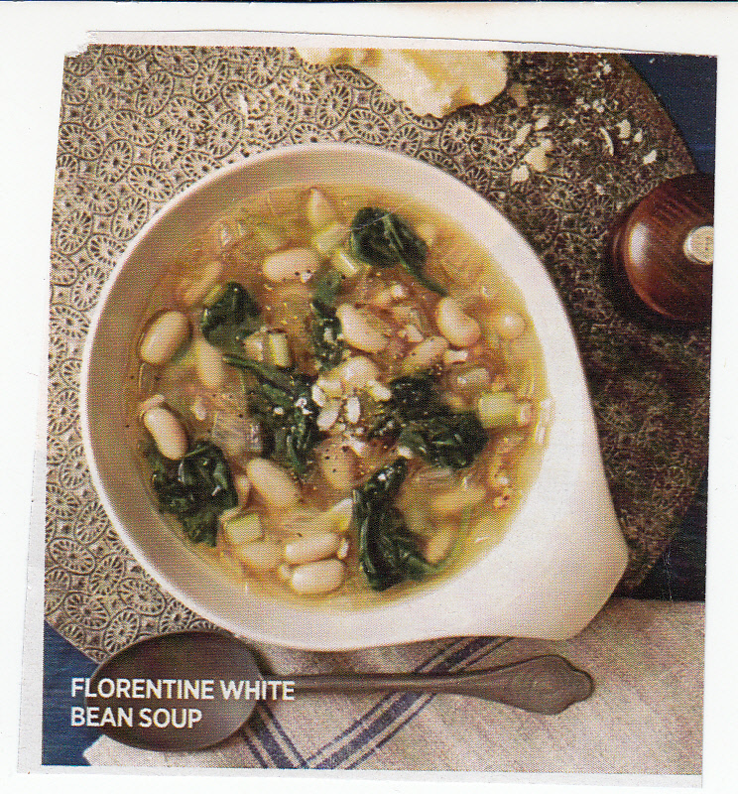
FLORENTINE WHITE BEAN SOUP
YOU WILL NEED:
1 TBS OLIVE OIL
4 OZ CHOPPED PANCETTA
2 MEDIUM ONIONS, CHOPPED
6 GLOVES, GARLIC SLICED
¼ TSP RED PEPPER FLAKES
4 CUPS REDUCED SODIUM CHICKEN BROTH
2 RIBS CELERY, CHOPPED
2 SPRINGS OF FRESH ROSEMARY
15 OZ CAN OF WHITE CANNELLINI BEANS
1 (8 OZ) BAG OF BABY SPINACH, CHOPPED
1 TSP SALT (OPTIONAL) OR SALT TO TASTE
½ TSP BLACK PEPPER
1/3 CUP GRATED PARMESAN CHEESE

IN A LARGE SOUP POT, HEAT OIL OVER MEDIUM-HIGH HEAT. ADD PANCETTA, ONIONS, GARLIC AND RED PEPPER FLAKES. COOK FOR APPROX. 6 MINUTES, STIRRING OCCASIONALLY. STIR IN CHICKEN BROTH, CELERY, ROSEMARY AND 2 CUPS OF WATER. COVER AND SIMMER FOR 20 MINUTES. ADD WHITE BEANS AND SPINACH, SEASON WITH SALT AND PEPPER, AND SIMMER FOR 10 MORE MINUTES.

TO SERVE, SPRINKLE WITH PARMESAN CHEESE.

