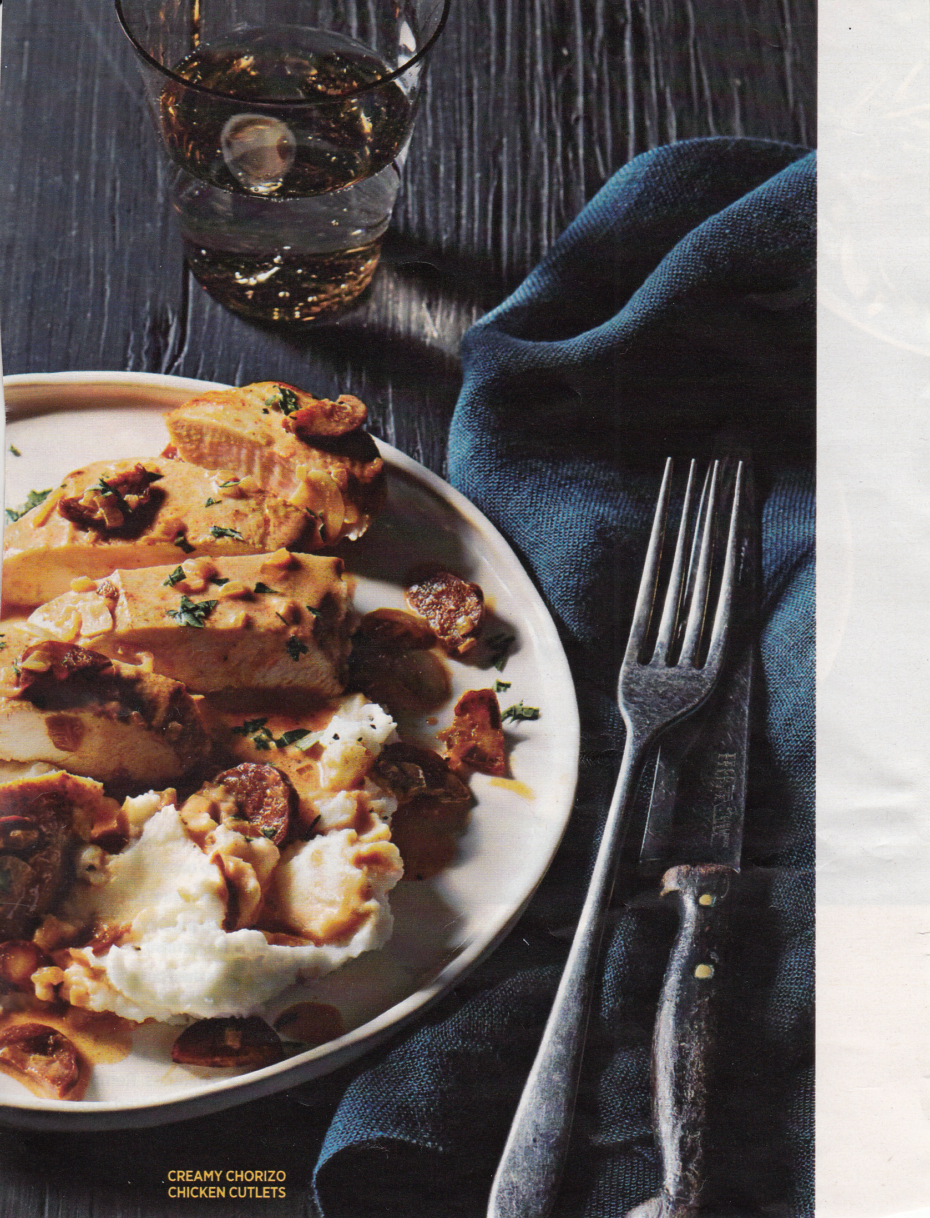

CREAMY CHORIZO CHICKEN CUTLETS
YOU WILL NEED:
1 TBS OLIVE OIL
3 OUNCES SPANISH STYLE CURED CHORIZO SAUSAGE, CASING REMOVED, QUARTERED AND SLICED
4 BONELESS CHICKEN BREASTS (HALVES) POUNDED OUT TO ½ INCH THICKNESS
1 TSP SWEET PAPRIKA
½ TSP PLUS 1/8 TSP SALT
¼ TSP PEPPER
¼ CUP FINELY DICED SHALLOTS
3 CLOVES GARLIC, SLICED
½ TSP SMOKED PAPRIKA
1 CUP UNSALTED CHICKEN BROTH
½ CUP CREAM CHEESE
¼ CUP PARSLEY, CHOPPED FOR GARNISH
IN A LARGE POT, HEAT OIL OVER MEDIUM HEAT. ADD CHORIZO AND COOK FOR 3 MINUTES. REMOVE TO A PLATE WITH A SLOTTED SPOON. SEASON CHICKEN ON BOTH SIDES WITH ½ TSP OF SWEET PAPRIKA, ½ TSP SALT AND THE PEPPER. INCREASE HEAT (SAME POT) TO MEDIUM HIGH. BROWN CHICKEN IN DRIPPINGS FOR 2 MINUTES PER SIDE. REMOVE CHICKEN TO PLATE WITH CHORIZO. IN SAME POT AND DRIPPINGS, STIR IN SHALLOTS, GARLIC, REMAINING ½ TSP OF SWEET PAPRIKA AND THE SMOKED PAPRIKA. COOK 2 MINUTES. POUR IN CHICKEN BROTH AND REMAINING 1/8 TSP SALT, SCRAPING BOTTOM OF PAN. BRING TO A SIMMER. WHISK IN CREAM CHEESE UNTIL MELTED, RETURN CHORIZO AND CHICKEN, COOK FOR ONE MINUTE. GARNISH WITH PARSLEY AND SERVE WITH MASHED POTATOES OR EGG NOODLES.
THIS RECIPE IS FROM FAMILY CIRCLE MAGAZINE.

