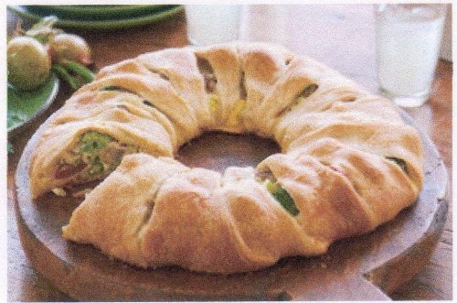EASY BAKE CHEESE AND VEGETABLE TWIST
YOU WILL NEED:
2 EGGS
4 OUNCES PHILLY CREAM CHEESE, SOFTENED
½ CUP KRAFT 2% MILK SHREDDED ITALIAN THREE CHEESE BLEND
3 CUPS FROZEN BROCCOLI CUTS, THAWED, DRAINED
½ LB FRESH MUSHROOMS, CUT INTO QUARTERS
½ CUP CHERRY TOMATOES, CUT IN HALF
4 GREEN ONIONS, SLICED
2 CANS (8 OZ. EACH) REFRIGERATED CRESENT DINNER ROLLS
DIRECTIONS:
HEAT OVEN TO 375 DEGREES.
MIX FIRST 3 INGREDIENTS IN A LARGE BOWL UNTIL WELL BLENDED, STIR IN NEXT 4 INGREDIENTS.
UNROLL DOUGH, SEPARATE INTO 16 TRIANGLES. ARRANGE DOUGH IN AN 11 INCH CIRCLE ON A FOIL COVERED BAKING SHEET, WITH SHORT SIDES OF TRIANGLE OVERLAPING IN CENTER AND POINTS OF TRIANGLES POINTING TOWARD THE OUTSIDE. THERE SHOULD BE A 5 INCH DIAMETER OPENING IN THE CENTER OF THE CIRCLE. SPOON CHEESE MIXTURE ONTO THE DOUGH NEAR CENTER OF CIRCLE. BRING OUTSIDE PIOINTS OF TRIANGLES UP OVER FILLING, THEN TUCK UNDER DOUGH IN CENTER (SHORT END OF DOUGH) TO COVER FILLING.
BAKE FOR 35 TO 40 MINUTES UNTIL CRUST IS GOLDEN BROWN AND FILLING IS HEATED THROUGH.
THIS RECIPE IS FROM KRAFT

